# OOP Basics Exam – Minedraft

You ever heard about the Rick and Morty’s Foundation for mining Plumbus Ore. Naaa, probably not. Well let’s just say there is this company that mines things, and they hired you to write them a supervising software. A draft which will be used to analyze the data of the mining – a … Minedraft.

### Overview

The main system consists of Harvesters and Providers. The Harvesters are the ones that make real money – they mine Plumbus Ore. But they need a large amount of energy to do that. That’s where the Providers come. The Providers are the ones that provide the energy for the harvesters.

## Task 1: Structure

The Structure consists of Harvesters and Providers.

### Harvesters

A basic Harvester has the following properties:

* id – a **string**.
* oreOutput – a **floating-point number**.
* energyRequirement – a **floating-point number**.

For all harvesters you **need to validate**, that **ore output** and **energy requirement** for each harvester **is NOT negative**. Also you need to **validate** that **energy requirement** for each harveter **is NOT over 20000**. There are generally **2** types of Harversters:

#### SonicHarvester

Really fast… Has an extra property:

* sonicFactor – an **integer**.

**UPON INITIALIZATION**, **divides** its given energyRequirement by its sonicFactor.

#### HammerHarvester

Heavy... and big.

**UPON INITIALIZATION**, **increases** its oreOutput by **200 %,** and **increases** its energyRequirement by **100 %**.

### Providers

A basic Provider has the following properties:

* id – a **string**.
* energyOutput – a **floating-point number**.

Every provider energy output **need to be positive numbers,** **less than 10000**. There are generally **2** types of Providers:

#### SolarProvider

Extracts energy from the Sun. Nothing special here.

#### PressureProvider

Extracts energy from deep beneath the earth. Temperatures and Pressure affect it.

**UPON INITIALIZATION**,increases its energyOutput by **50 %**.

## Task 2: Business Logic

### The Controller Class

The business logic of the program should be concentrated around several commands. Implement a class called DraftManager, which will hold the **main functionality**, represented by these **public** **methods**:

|  |
| --- |
| DraftManager.cs |
| string RegisterHarvester(List<string> arguments)  {  //TODO: Add some logic here …  }  string RegisterProvider(List<string> arguments)  {  //TODO: Add some logic here …  }  string Day()  {  //TODO: Add some logic here …  }  string Mode(List<string> arguments)  {  //TODO: Add some logic here …  }  string Check(List<string> arguments)  {  //TODO: Add some logic here …  }  string ShutDown()  {  //TODO: Add some logic here …  } |

**NOTE: DraftManager class** methods are called from the outside so these methods **must** **NOT** receive the command parameter as part of the arguments!

### Functionality

The whole system works on **3 modes** – “**Full Mode**”, “**Half Mode**”, “**Energy Mode**”. Depending on the mode, the Harvesters and Providers work differently. By **DEFAULT** the mode is “Full Mode”.

The Providers and Harvesters have **ids**, which will **always** be **unique**.

When a **day passes**, the Providers produce energy and the Harvesters consume energy and mine Plumbus Ore. In your program a **day passes** when you have been given the **corresponding command**.

The Providers produce energy which is being stored on the system. When there is **ENOUGH** **energy** to **power up** **ALL** Harvesters, the Harvesters **consume** it and return the ore.

The system keeps the totalStoredEnergy and the totalMinedOre.

### Modes

The different modes make the Harvesters work differently. You can save more power by changing the modes and stalling them a little. The Providers remain **unaffected** by the modes.

##### Full Mode

All Harvesters consume their **FULL energy requirements**, and produce their **FULL ore output**.

##### Half Mode

All Harvesters consume **60 %** of their **energy requirements**, and produce **50 %** of their **ore output**.

##### Energy Mode

The Harvesters consume **nothing**, and produce **nothing**. They practically do **NOT** work.

### Commands

There are several commands that control the business logic of the application you are supposed to build.   
They are stated below.

#### RegisterHarvester Command

Creates a Harvester, and registers it into the system, so they can start mining when new day come.

##### Parameters

* type – a **string**, equal to either Sonic or Hammer.
* id – a **string**.
* oreOutput – a positive **floating-point number**.
* energyRequirement – a positive **floating-point number**.

If the type is Sonic, you will receive **1 extra parameter**:

* sonicFactor – a positive **integer**.

#### RegisterProvider Command

Creates a Provider, and registers it into the system. They start to provide energy from next day.

##### Parameters

* type – a **string**, equal to either Solar or Pressure.
* id – a **string**.
* energyOutput – a positive **floating-point number**.

#### Day Command

When you receive this command a day passes. This is the moment where real work starts. You need to **calculate** all the provided **energy** and **STORE** it in the system. Then you need to **check** if there is **enough** **energy** for harvesters to start mining. If the sum of energy requirement of **ALL** harvesters is more than the **energy** **stored** then **NOTHING** happens. If there is **enough energy**, **ALL** harvesters **start mining** and they **consume** from the **stored** **energy** **EQUAL** to their energy requirement.

**NOTE**: The summed up energyRequirement might be **less** or **more** depending on the current **working** **Mode**.

#### Mode Command

Changes the **mode** of the system, to the **given one**.

##### Parameters

* mode - a **string**, equal to either Full, Half or Energy.

#### Check Command

**Checks** the Provider or the Harvester with the **given id**, returning a **string representation** of it. The system should check if there is an **element** with the **given id** among the Providers or the Harvesters. The **ids** are **unique** so there should be only **one** with that **id**.

##### Parameters

* id – a **string**.

#### Shutdown Command

**Ends** the program and **print total energy stored and ore mined**

## Task 3: Input / Output

### Input

Below, you can see the **format** in which **each command** will be given in the input:

* RegisterHarvester {type} {id} {oreOutput} {energyRequirement}
* RegisterHarvester Sonic {id} {oreOutput} {energyRequirement} {sonicFactor}
* RegisterProvider {type} {id} {energyOutput}
* Day
* Mode {mode}
* Check {id}
* Shutdown

### Output

Below you can see what output should be provided from the commands.

#### RegisterHarvester Command

Successful command should print “Successfully registered {type} Harvester – {id}”.

Unsuccessfull comand: "Harvester is not registered, because of it's {propertyName}"

#### RegisterProvider Command

Should output a message “Successfully registered {type} Provider – {id}”.

Unsuccessfull comand: "Provider is not registered, because of it's {propertyName}"

#### Day Command

Should output a message

“A day has passed.

“Energy Provided: {summedEnergyOutput}”.

“Plumbus Ore Mined: {summedOreOutput}”.

The summedEnergyOutput and summedOreOutput are the ones that have been mined for the day.

#### Mode Command

Should output a message “Successfully changed working mode to {mode} Mode”.

#### Check Command

Should return a **string representation** of the element with the **given id**. If there is no such element, the command should output a message “No element found with id – {id}”.

Because the element can either be a Provider or a Harvester, both **output formats** have been provided below:

|  |  |
| --- | --- |
| Harvester | Provider |
| “{type} Harvester – {id}  Ore Output: {oreOutput}  Energy Requirement: {energyRequired}” | “{type} Provider – {id}  Energy Output: {energyOutput}” |

#### Shutdown Command

Should output a message

“System Shutdown

Total Energy Stored: {totalEnergyStored}

Total Mined Plumbus Ore: {totalMinedOre}”.

The totalEnergyStored and totalMinedOre are the total values that have been gathered throughout the program’s execution.

### Constraints

* The id will be a string which may contain any ASCII character, except **space** (‘ ’).
* The ids will always be **unique**.
* All **floating-point numbers** will be in **range [-1.000.000, 1.000.000]**.
* The sonicFactor will be in **range [1, 10]**.
* There will be **NO invalid** input data.

### Examples

|  |  |
| --- | --- |
| **Input** | **Output** |
| RegisterHarvester Sonic AS-51 100 100 10  RegisterHarvester Hammer CDD 100 50  RegisterProvider Solar Falcon 100  Day  Check AS-51  Check CDD  Check Falcon  Day  Shutdown | Successfully registered Sonic Harvester - AS-51  Successfully registered Hammer Harvester - CDD  Successfully registered Solar Provider - Falcon  A day has passed.  Energy Provided: 100  Plumbus Ore Mined: 0  Sonic Harvester - AS-51  Ore Output: 100  Energy Requirement: 10  Hammer Harvester - CDD  Ore Output: 300  Energy Requirement: 100  Solar Provider - Falcon  Energy Output: 100  A day has passed.  Energy Provided: 100  Plumbus Ore Mined: 400  System Shutdown  Total Energy Stored: 90  Total Mined Plumbus Ore: 400 |
| RegisterHarvester Sonic AS-51 100 1000000 10  RegisterHarvester Hammer CDD 100 50  RegisterProvider Solar Falcon 100  RegisterProvider Solar Pesho 100000  Day  Check CDD  Check Falcon  Day  Shutdown | Harvester is not registered, because of it's EnergyRequirement  Successfully registered Hammer Harvester - CDD  Successfully registered Solar Provider - Falcon  Provider is not registered, because of it's EnergyOutput  A day has passed.  Energy Provided: 100  Plumbus Ore Mined: 300  Hammer Harvester - CDD  Ore Output: 300  Energy Requirement: 100  Solar Provider - Falcon  Energy Output: 100  A day has passed.  Energy Provided: 100  Plumbus Ore Mined: 300  System Shutdown  Total Energy Stored: 0  Total Mined Plumbus Ore: 600 |
| RegisterProvider Pressure Deep-1 1000  RegisterProvider Pressure Deep-3 2000  Day  Mode Energy  RegisterHarvester Hammer S-1 10000 11250  Day  Check Something  Check S-1  Mode Half  Day  Shutdown | Successfully registered Pressure Provider - Deep-1  Successfully registered Pressure Provider - Deep-3  A day has passed.  Energy Provided: 4500  Plumbus Ore Mined: 0  Successfully changed working mode to Energy Mode  Harvester is not registered, because of it's EnergyRequirement  A day has passed.  Energy Provided: 4500  Plumbus Ore Mined: 0  No element found with id - Something  No element found with id - S-1  Successfully changed working mode to Half Mode  A day has passed.  Energy Provided: 4500  Plumbus Ore Mined: 0  System Shutdown  Total Energy Stored: 13500  Total Mined Plumbus Ore: 0 |

## Task 4: Bonus

### Abstraction

Probably, you have already noticed, that there is a way to **improve** the **abstraction** of your code. If NOT, now is the time to think about this. For this task, you need **one more level of abstraction for Harvester and Providers**.

### Factories

You know, that the keyword **new** is a bottleneck and we are trying to use it as less as possible. We even try to separate it in new classes. These classes are called Factories and the convention for them is **{TypeOfObject}Factory.** You need to have **two** **different** **factories**, **one for Harvesters and one for Providers**. This is actually a design pattern and you can read more about it. [Factory Pattern](https://www.dotnetperls.com/factory)

## Points

For all tasks you can submit same project. Every different task give you points:

1. 100 points
2. 200 points
3. 100 points
4. 50 points

## Министерство на образованието и науката (МОН)

* Настоящият курс (презентации, примери, задачи, упражнения и др.) е разработен за нуждите на Национална програма "**Обучение за ИТ кариера**" на МОН за подготовка по професия "Приложен програмист".

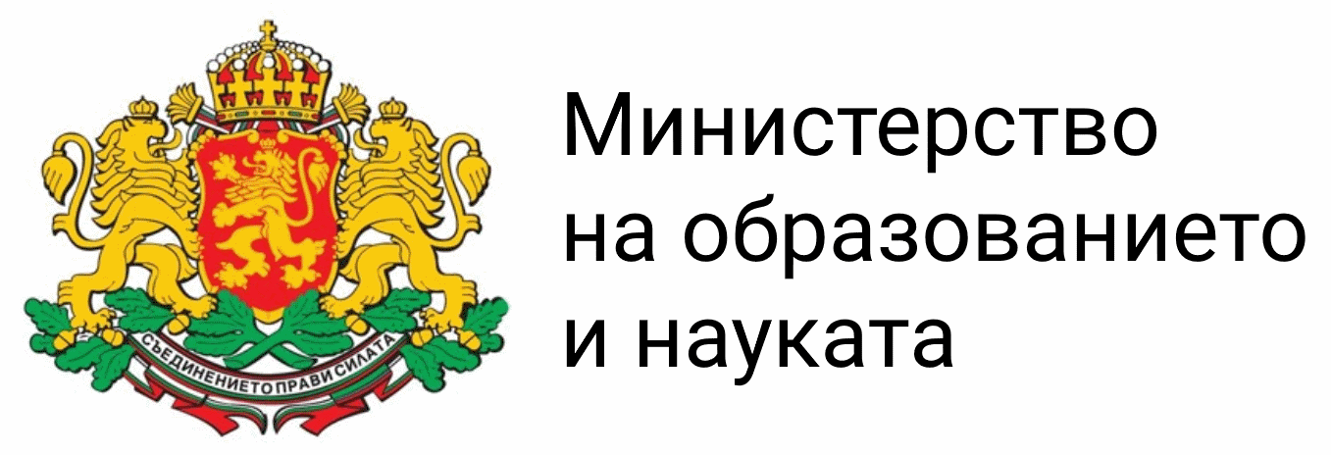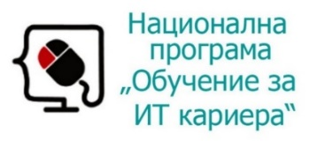

* Курсът е базиран на учебно съдържание и методика, предоставени от **фондация "Софтуерен университет"** и се разпространява под **свободен** **лиценз CC-BY-NC-SA** (Creative Commons Attribution-Non-Commercial-Share-Alike 4.0 International).

